JS LAB

Create a Web Project that captures Employee details for performing tax calculation of an Employee.

Create a TaxCalculator App for the below requirements

1. Create 3 forms to perform add Employee, search Employee and Display Salary Report of an Employee
2. Create a form capturing Employee details mentioned below for adding an Employee
   * Name (full name of an employee)
   * Employee Id (to uniquely identify an employee). Currently, no DB integration
   * Role Name (current role to be displayed as mentioned below
   * Date of Joining (if user doesn’t enter any value, by default today’s date)

(Let role name be selected from a drop- down)

[Junior Software Developer, Senior Software Developer, Junior Quality Analyst, Senior Quality Analyst, Business Analyst, Team Lead, Manager]

**Note: Use any Browser storage feature offered by HTML5**

1. Create a form capturing employee id to be searched. Display the employee details captured while adding an employee
2. Create a form capturing employee id, investments (annual or monthly if any for tax deductions) and assessment year for calculating the tax details of Employee. Display below details in the Salary Report
   1. a. Name
   2. b. Employee Id
   3. c. Role Name
   4. d. Joining Date
   5. e. Basic
   6. f. Allowances
   7. g. Bonus
   8. h. Gross Annual Salary
   9. i. Taxable Income
   10. j. Tax Payable
   11. k. Annual Net Salary
3. To solve the above stated problem, consider using the below domain rules

For every role, let basic be assigned as follows:-

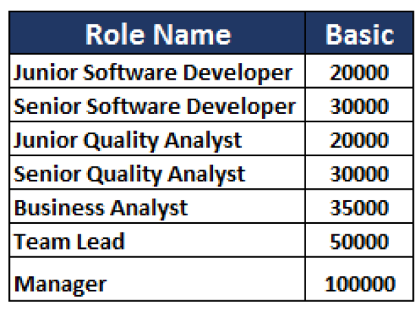

1. Create a javascript file to implement tax calculation of an Employee
   * Create an employee that constructs an object of Employee
   * Create functions performing below calculations
     + - Calculate monthly gross salary (basic + allowances)
       - Calculate annual gross salary (monthly gross salary + bonus).

Bonus must be calculated based on the role. The percentage of bonus is

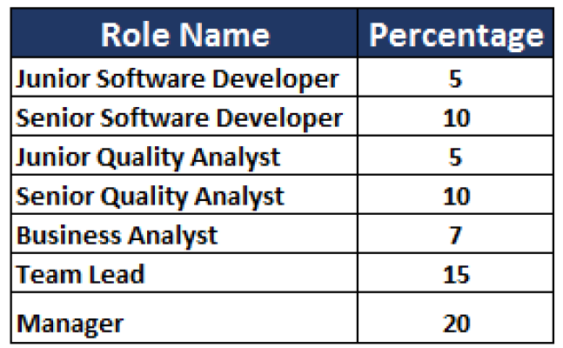

* Create a function to show Salary report along with Tax Calculation of an Employee with maximum non-taxable income of **150000** for the fiscal years **(2016-17, 2017-18 and 2018-19)** and **200000** for fiscal year **(2019-20)** with tax percentage calculated as follows: -

